1. **Paramecium**

|  |  |
| --- | --- |
| Domain: | [Eukaryota](https://en.wikipedia.org/wiki/Eukaryota) |
| Phylum: | [Ciliophora](https://en.wikipedia.org/wiki/Ciliophora) |
| Class: | [Oligohymenophorea](https://en.wikipedia.org/wiki/Oligohymenophorea) |
| Order: | [Peniculida](https://en.wikipedia.org/wiki/Peniculida) |
| Family: | [Parameciidae](https://en.wikipedia.org/wiki/Parameciidae) |
| Genus: | ***Paramecium*** |

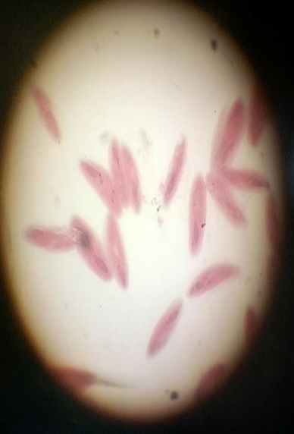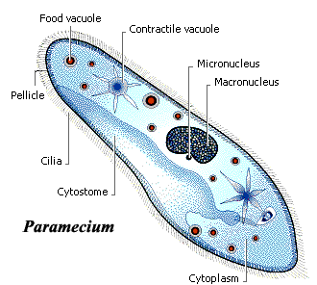

1. Paramecium is a unicellular protozoan belonging to ciliates group. Members of this group are characterized by their external covering of continuously beating, hair-like cilia.

2. The cell is rounded at the front and pointed at the back.

3. They possess one macronucleus and at least one micronucleus.

4. Visible within the cytoplasm are two, large, sporadically contracting vacuoles at either end of the cell. The contraction of these vacuoles expels water from the cell as a means of balancing its salt concentration.

5. The buccal cavity, or oral region is located toward the anterior of the cell. This orifice is lined with highly organized rows of beating cilia which draw food particles.

6. There is an opening near the back end called the anal pore.

**2. Bread Moulds (Rhizopus)**

|  |  |
| --- | --- |
| Kingdom: | [Fungi](https://en.wikipedia.org/wiki/Fungi) |
| Division: | [Zygomycota](https://en.wikipedia.org/wiki/Zygomycota) |
| Class: | [Mucoromycotina](https://en.wikipedia.org/wiki/Mucoromycotina) |
| Order: | [Mucorales](https://en.wikipedia.org/wiki/Mucorales) |
| Family: | [Mucoraceae](https://en.wikipedia.org/wiki/Mucoraceae) |
| Genus: | ***Rhizopus*** |

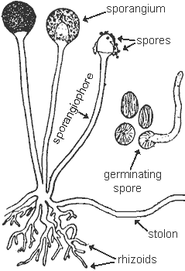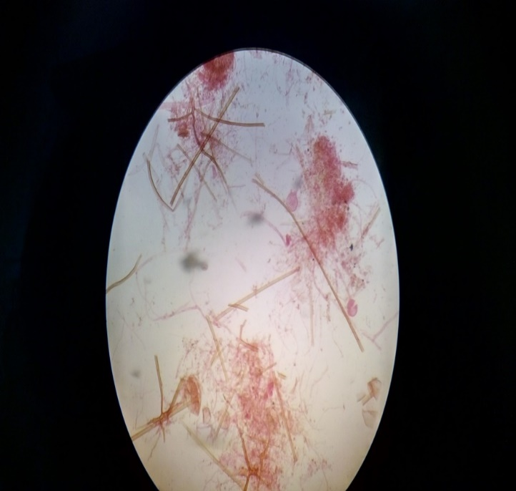

1. Moulds are microscopic, plant-like organisms, composed of long filaments called hyphae.

2. Hyphae contain cytoplasm & nuclei and have a cell wall of chitin.

3. A tangled mass of hyphae visible to the unaided eye is a **mycelium** (plural, **mycelia**).

4. Stolon is a horizontal hyphae that connects groups of hyphae to each other.

5. Rhizoids are root like parts of hyphae that anchor the fungus.

6. Fruiting bodies are modified hyphae that make asexual spores.

7. Fruiting bodies consist of an upright stalk or sporangiophore with a sac containing spores called the sporangium.

7. They are eukaryotic, do not contain chlorophyll and are hence non-photosynthetic.

8. They lack true root, stem and leaves.

1. **Xylem**

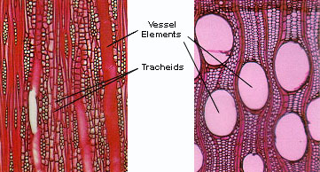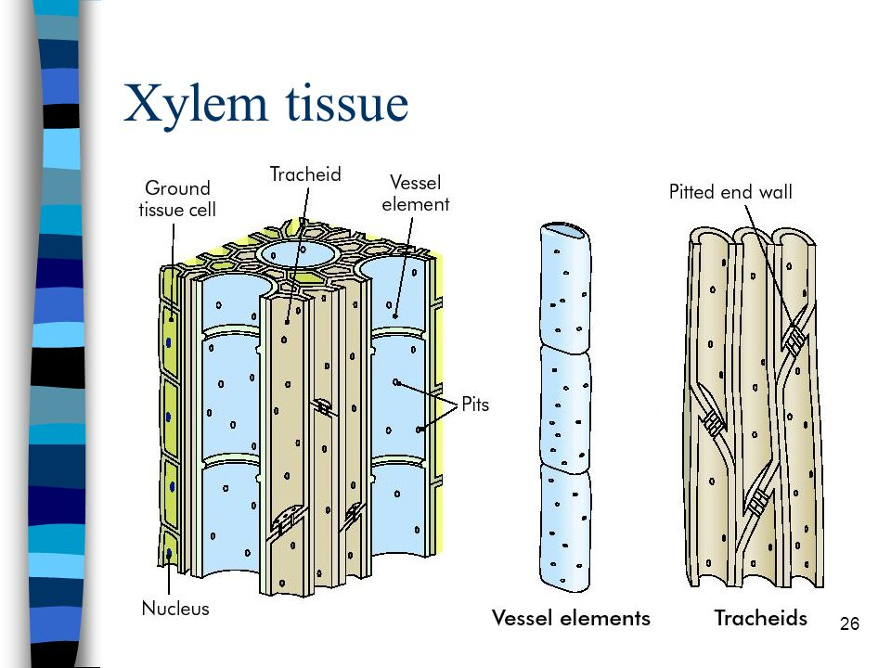

**LS** **TS**

1. Xylem is the water and mineral conducting tissue in plants
2. Xylem cells are thick-walled, tubular cells impregnated with lignin (complex carbohydrates). The lignin makes the cell waterproof, and this causes the cells to die.

3. The cells are placed end to end like drain pipes, and the partitions between the cells eventually dissolve to form long pipelines for the transport of water and minerals.

4. The tubes are narrow so the water column does not break easily and capillary action can be effective.

5. Xylem tissue consists of primarily two kinds of cells: tracheid and vessels. Tracheid are long and tapered, with angled end-plates that connect cell to cell. Vessel elements are shorter, much wider and lack end plates.

6. In most angiosperms (flowering plants), the xylem contains fibres along with vessel elements. While the vessel elements have a larger diameter and are specialized for water transport, fibres provide mechanical strength to the tissue.

**4. Phloem**

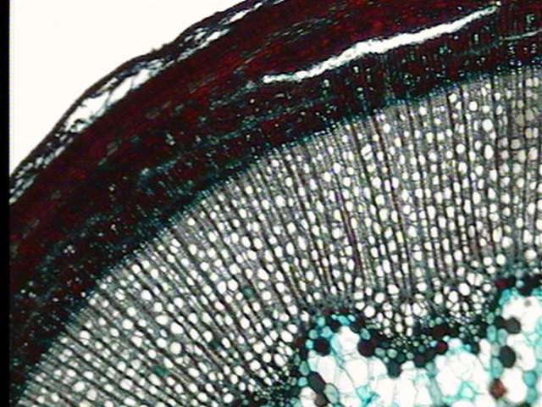 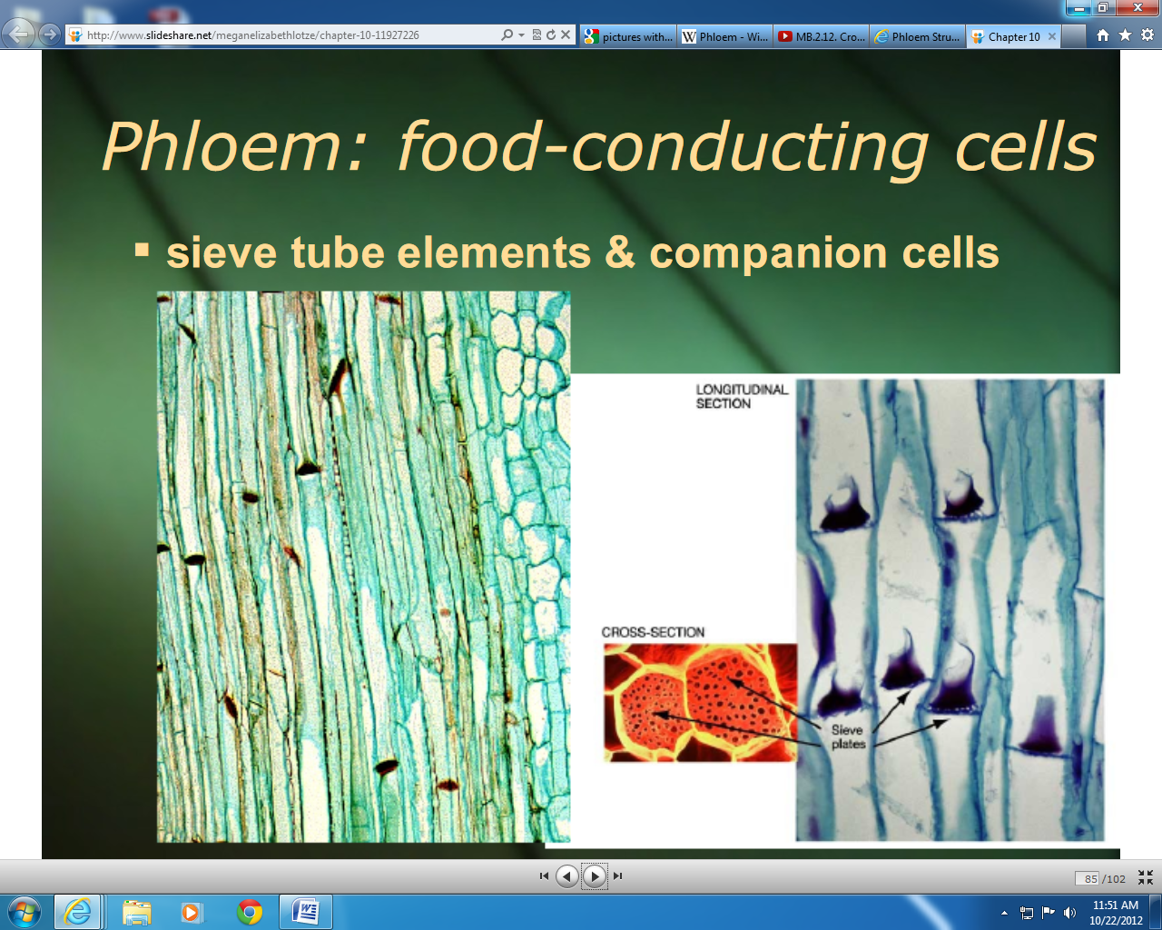

1. Phloem tissue consists of two types of cell: sieve tube elements and companion cells which conduct food from leaves to rest of the plant. They are alive at maturity and are usually located outside the xylem. Unlike xylem they are soft-walled.

2. The sieve tube elements are not true cells as they contain very little cytoplasm and no nucleus. They are lined up end-to-end to form a tube, which transports the sugars (sap).

3. Unlike xylem, this tube contains cross-walls at intervals, perforated by many pores to allow the sap to flow. Hence the cross-walls are called sieve plates and the tubes are called sieve tubes.

4. Between the sieve tubes are small cells, each with a large nucleus and dense cytoplasm. Because of their many active processes, they have large numbers of mitochondria to produce ATP. These cells carry out the metabolic processes using the ATP energy, such as loading the sucrose in the tubes.

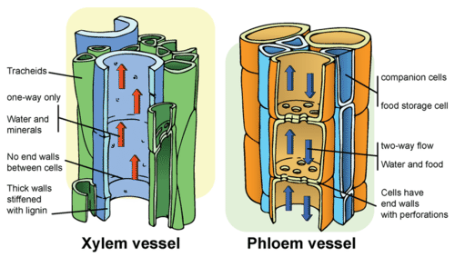

**5. Duodenum**

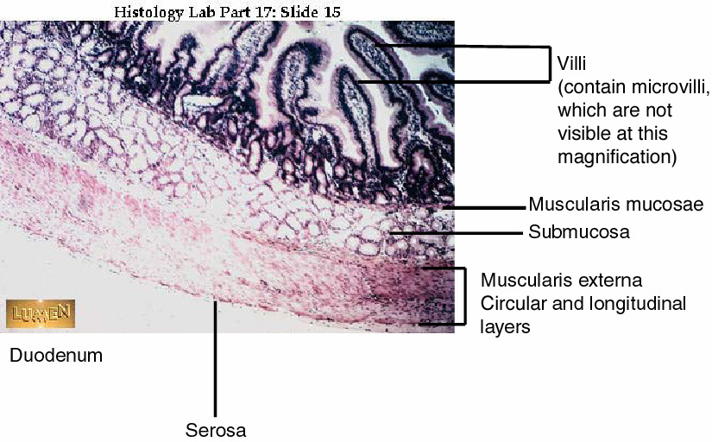 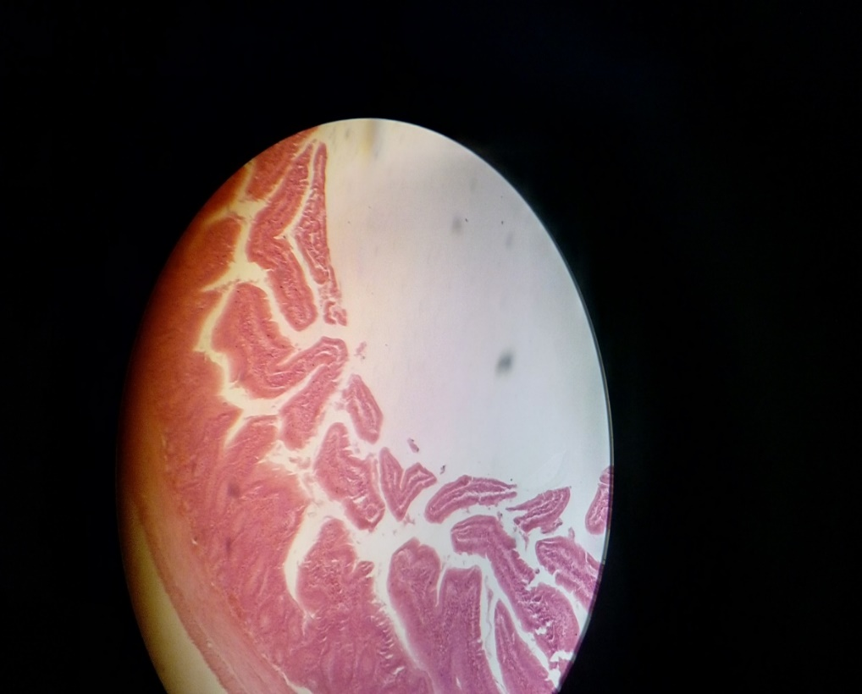

1. The small intestine is divided into three sections; the **duodenum**, **jejunum** and the **ileum**.

The duodenum is the first section where secretions from the pancreas and liver are added

to the chyme which has entered the small intestine from the stomach.

1. The epithelium of the mucosa is a regular simple columnar form (with goblet cells)
2. Tunica Muscularis is a layer of smooth muscle which is positioned differently in inner circular layer and outer longitudinal layer.
3. The **intestinal mucosa** is the innermost lining of the small intestine that shapes itself into **villi**; invaginations of the mucosa that greatly increase the surface area of the small intestine for absorption of nutrients. Digested food molecules come into direct contact with the mucosa which is responsible for the absorption of the nutrients. Each villus contains a network of **capillaries** and a **lacteal**.
4. Brunner's glands, which secrete mucus, are found in the duodenum

**6. T.S. Oesophagus**

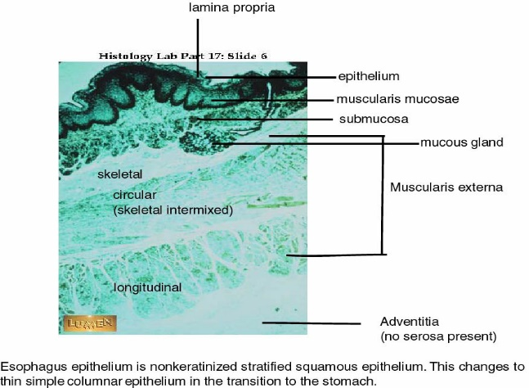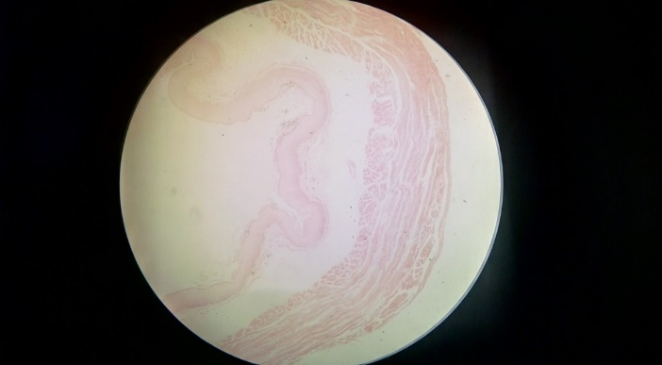

1. The esophagus is essentially a long, flattened tube lined by non-keratinized stratified squamous epithelium (multiple layers of scale like cells).

## At the anterior end it receives a food bolus from the pharynx which it discharges into the stomach through the posterior end.

1. There is a thick muscular wall called sub-mucosa that provides the muscular strength to propel swallowed material into the stomach. It also contains submucosal glands.

## The lumen (L) is surrounded by the tunica mucosa (M). The tunica submucosa (S) is seen here as a space between the tunica mucosa and the muscularis externa. The tunica muscularis externa (TM) contains both skeletal and smooth muscle fibers.

## In some species (dogs, ruminants, horses) the entire tunica muscularis externa of the esophagus is composed of skeletal muscle; in birds it is entirely smooth muscle; and in most animals it makes a transition from skeletal to smooth muscle about half-way down. These features can be used as landmarks to identify the organ and to determine where the section was taken from.

1. The contractions of the tunica muscularis push the food along its short journey to the stomach and these are controlled by an amazingly complex array of nerve fibers. The act of swallowing food is a sort of high speed peristalsis, partially voluntary in nature, and very tightly controlled.

**7. Artery**

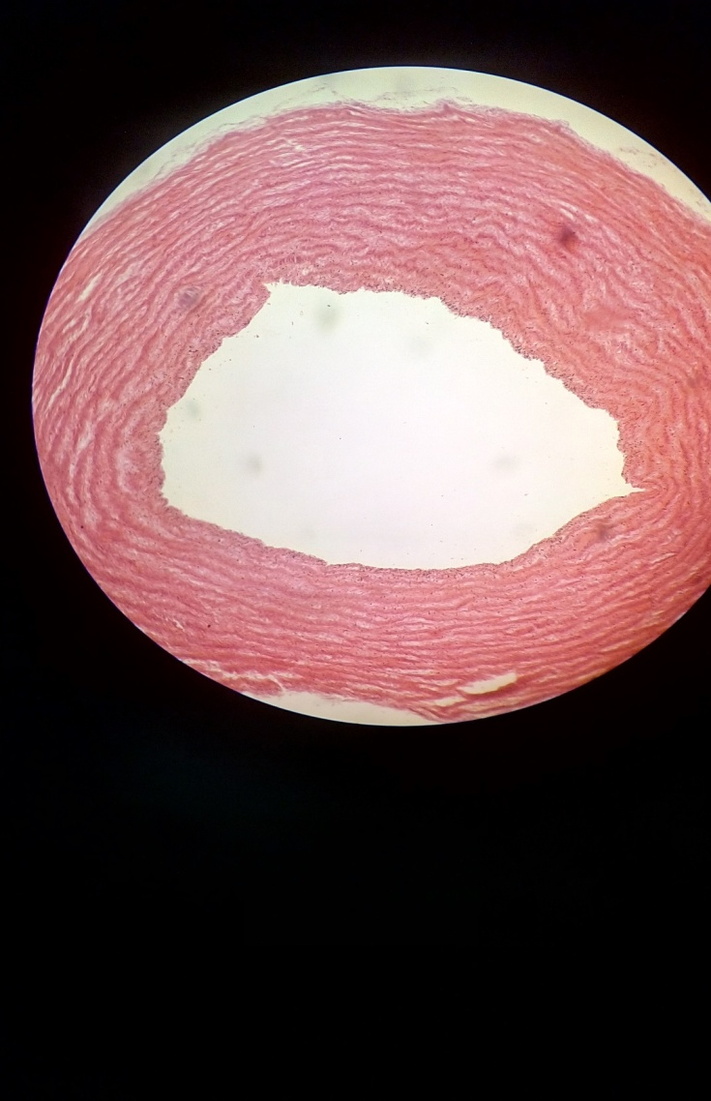

1. Systemics arteries can be subdivided into two types - muscular and elastic
2. The larger arteries (>10mm diameter) are generally elastic and the smaller ones (0.1-10mm) tend to be muscular.
3. The walls of arteries, arterioles, veins, and venules all have three layers, or tunics.

* The innermost layer is the tunica intima, which consists of an endothelial tube of longitudinally arranged, simple, squamous epithelial cells termed *endothelial cells.*
* The tunica media is composed of multiple concentric layers of circularly arranged smooth muscle cells.
* The tunica adventitia consists of fibrocytes, longitudinal bundles of collagen fibers, and a loose network of thin elastic fibers.

1. A sheet of elastic tissue, termed the *internal elastic membrane (internal elastic lamina),* forms the boundary between the tunica intima and the tunica media.
2. An external elastic membrane *(external elastic lamina)* serves as the boundary between the tunica media and the outermost layer of the vessel, the tunica adventitia.
3. In larger vessels you may find small blood vessels, termed *vasa vasorum,* within the tunica media. The vasa vasorum serve to nourish the vessel.

**8. Vein**

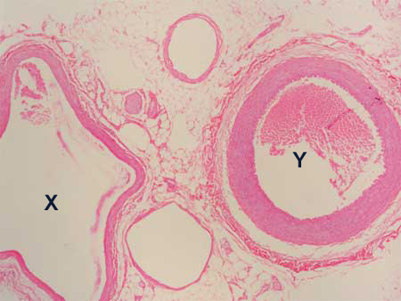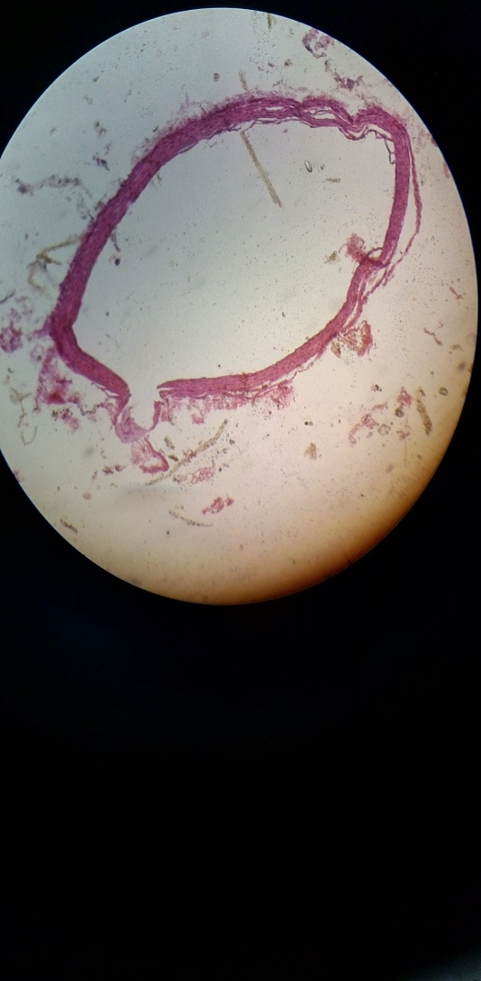

X= Vein; Y= Artery

1. Carry blood away from the heart so generally deoxygenated blood with exceptions of pulmonary and umbilical.
2. Three layers similar to the artery: Tunica externa, tunica media and tunica intima
3. Outer is made of connective tissues (collagen, vasa and nerve cells), the second is the band of smooth muscle (media), and interior lumen is lined with endothelial cells called tunica intima.
4. Only three to four layers of smooth muscle are seen within the tunica media of the vein. Veins in general are thin as veins do not function primarily in a contractile manner.
5. The artery has a thicker wall than the vein. This wall-thickness-to-lumen ratio is a major feature to consider when trying to identify arteries and veins. An artery will always have a larger wall-thickness-to lumen ratio than a vein of corresponding size.

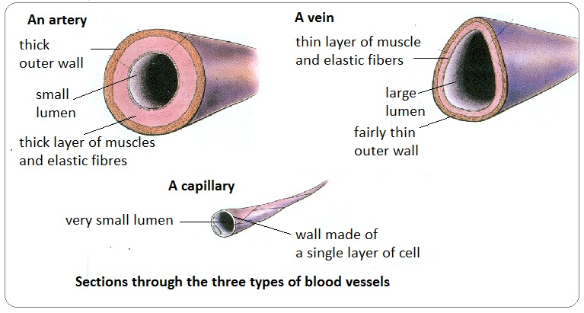

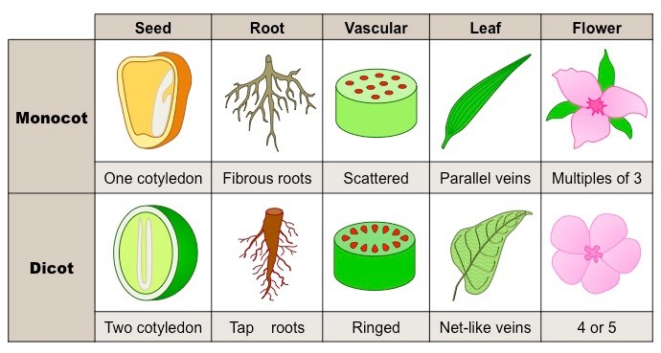

**9. Monocot Stem**

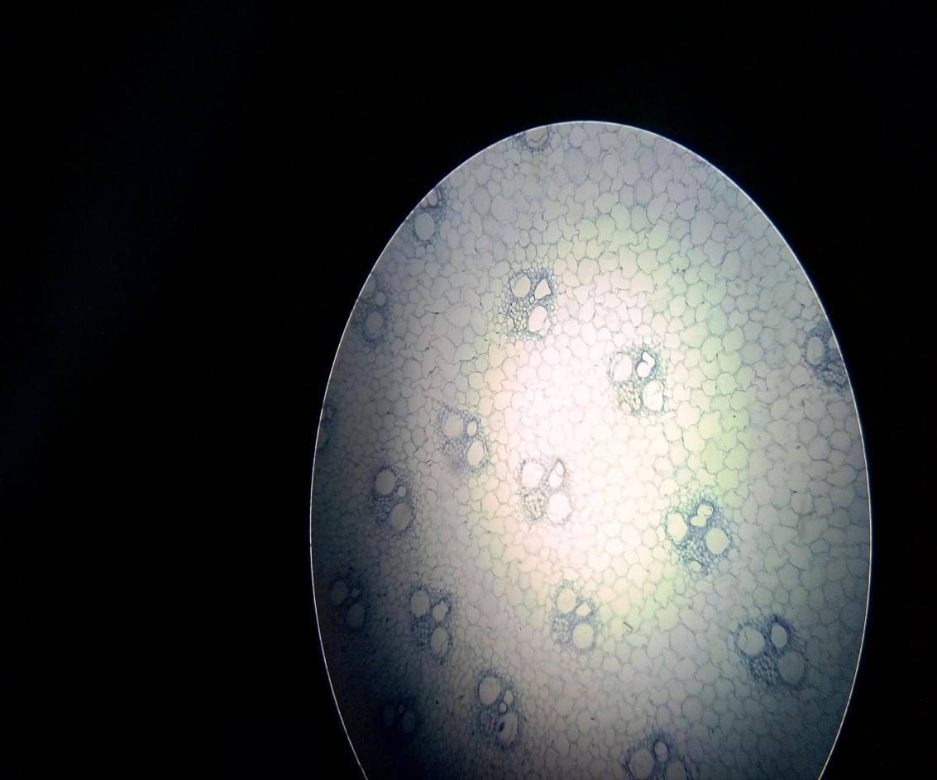 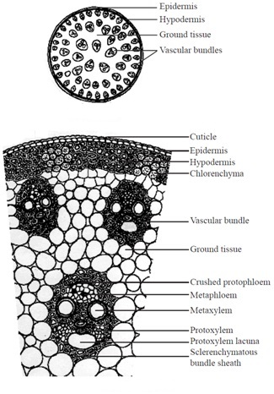

1. Vacular bundles scattered in ground tissue
2. Numerous Vacular bundles present
3. Bundle sheath present around the vascular bundles
4. Pith usually absent
5. No secondary thickening
6. Xylem elements are circular
7. Endodermis absent

**10. Dicot Stem**

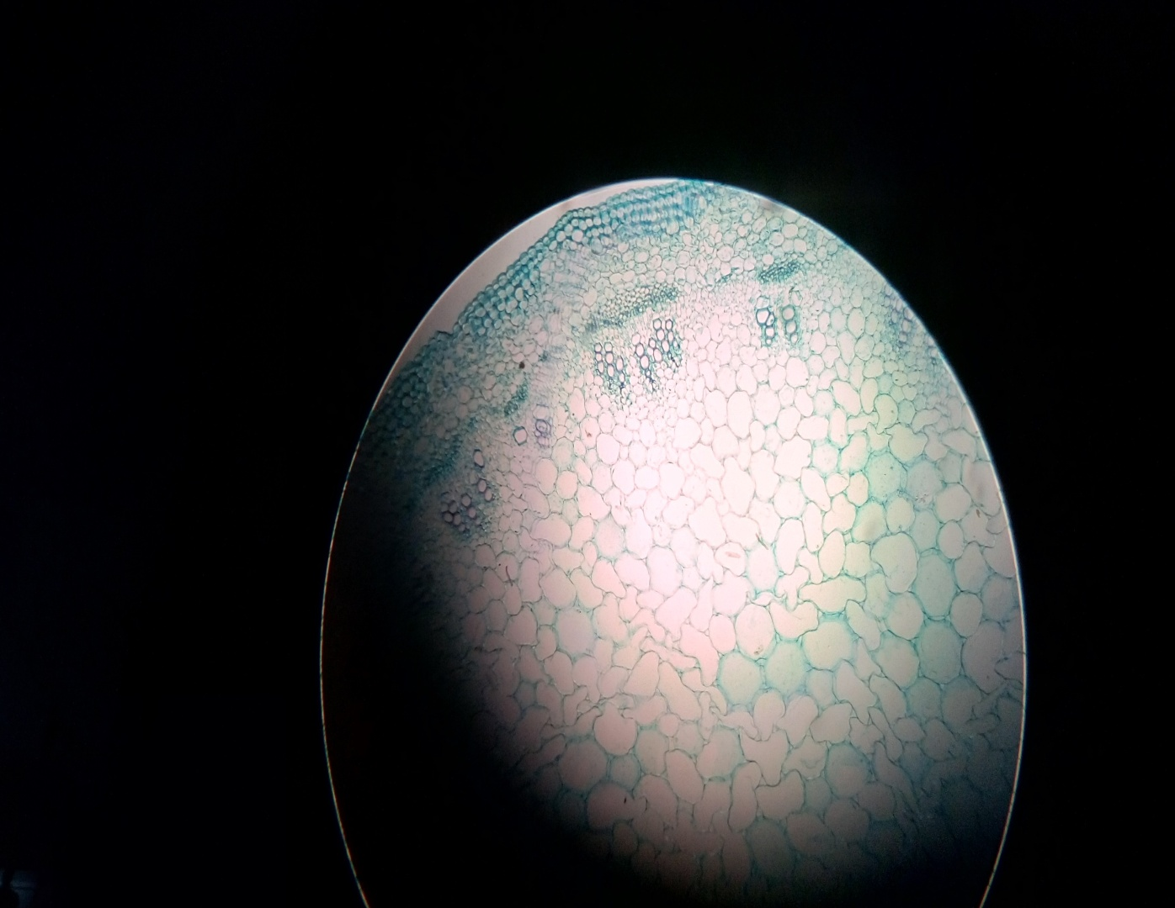 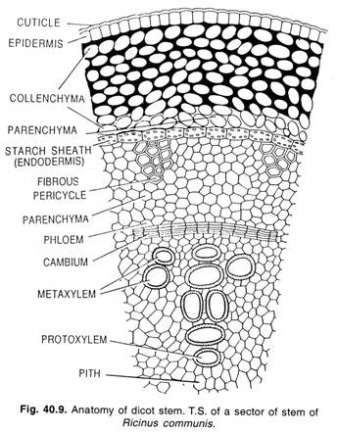

1. Multicellular epidermal hairs usually present
2. Endodermis present
3. Vacular bundles arranged in in one or two broken rings
4. Limited vascular bundles usually 4 to 8
5. Xylem elements are polygonal
6. Pith usually present
7. It undergoes secondary thickening

